

ELECTION RULES

Spring 2026

Version
Published:
03/02/2026

WHAT ARE THE ELECTIONS?
Elections are an opportunity for Brunel students to stand for positions within the Students’ Union, with the aim of representing the views of students to the relevant bodies. They happen throughout the academic year, and Students are able to vote in the election for their preferred representatives.

To do this we’re student-driven, led by democratically elected positions, and supported by full-time staff. We have elections to ensure that those people representing the views of students are the people you as students feel best to represent you. They also allow us to have a student leadership team to take a lead on projects and campaigns, ensuring your issues are being acted upon effectively.
INTRODUCTION

WHEN DO ELECTIONS HAPPEN?

Elections happen throughout the Academic year. We may also have the need to run the occasional by-election when a post has not been filled or has been vacated. Where possible we will run these as part of an existing election, although we may occasionally have to run a separate by-election.
In Spring 2026 we are electing our PT (voluntary) positions:
- Student Assembly Chair.
- BME Officer.
- Disabled Students Officer.
- Home Students Officer (2 places available, 1 for a woman)
- Women’s Officer.
- Gender, Diversity and Inclusion Officer.
- International Students Officer.
- Environment and Ethics Officer.
- LGBTQ+ Officer.

WHO IS RESPONSIBLE FOR ELECTIONS?

INTRODUCTION

All of our elections within the Union are overseen by the Elections Committee a committee of Union staff, University staff, external trustees and elected Officers. This committee is supported by the Deputy Returning Officer, the Head of Student Support and Representation. Their role is to make sure that all elections are conducted in a free and fair manner - developing the regulations which candidates must follow and then monitoring the conduct of the elections to ensure everyone follows these rules.

The fairness of Students’ Unions Elections is a requirement of law (Education Act, 1994) and this law places a level of responsibility on the University. In addition, the elections are conducted on university premises, by and for Brunel Students. As a result, the Union (and therefore the Elections Committee in this case) are answerable to the University and commit to abiding by agreements made between us. This also means that the University will take action against students and candidates who undermine the fairness of the election and whose conduct during the election is unacceptable according to these rules, our bye-laws or University regulations. Union governance and University regulations.

The Elections Committee will, therefore, take very seriously its role in overseeing the regulations- including those which put at risk the relationship between the Union and the University. Whilst we hope that this is not necessary The Elections Committee is granted powers by the Constitution to sanction students including candidates in relation to the elections. If The Elections Committee agrees that an action has impacted on the fairness of the Election process, they will look to redress the balance in some way, and if this proves impossible, they reserve the right to remove a candidate from the Election process. This process will be supported by the Deputy Returning Officer, who is ultimately responsible for deciding on sanctions against students and candidates. The Deputy Returning Officer for these elections is Ruth Sharma (Head of Student Support and Representation): ruth.sharma@brunel.ac.uk

THE RETURNING OFFICER

As a further and final commitment to ensuring open fair elections, the Unions constitution requires the appointment of an independent Returning Officer (RO). Their role is to oversee the entire elections process, provide guidance to the Elections Committee should they request it, and if necessary, hear appeals against the decision of the Elections Committee. They will also declare the elections- i.e., oversee the count of votes, and verify the results. The appointment of the RO is the responsibility of Student Assembly, and for this Academic year, NUS has been agreed as the Returning Officer. Constitutionally, their decision is final.

  - The Returning Officer is responsible for the overall good conduct and administration of elections, ensuring they are conducted in a free and fair manner.
  - The Returning Officer role ensures that the election is administered effectively and that, as a result, voters and those standing for election experience an accessible & fair process.
  - The Returning Officer delegates the day-to-day running of the elections to the Deputy Returning Officer.
  - Complaints (both formal and informal) should be dealt with by the Deputy Returning Officer. Appeals to DRO rulings on complaints, and complaints about the overall conduct of the election should be made to the Returning Officer.

Should anyone feel the need to contact the Returning Officer, they can do so by emailing Elections@brunel.ac.uk.

BECOMING A CANDIDATE

By nominating yourself as a candidate the Union understands that you take personal responsibility for ensuring you understand the rules, regulations and policies which govern the elections and the students’ union. We will make every effort to answer questions and have timetabled a series of opportunities to present these rules; however, it remains the responsibility of the candidate to understand the rules and ensure they do not breach them.

In order to become a candidate in the elections you are required to:

- Fill out the online nomination form correctly and have two proposers to approve your nomination. The proposer cannot have proposed anyone else for the same position.
- The DRO will contact the two proposers and if a proposer confirms that they did not propose the candidate the candidate will be withdrawn as this is considered as fraud.
- Upload a picture (max 1MB and must be JPEG) and manifesto (max 1000 words).
- Attend a Candidates Briefing. Cameras must be on, and you must attend the full session.
- If you fail to attend the briefing session, you will be withdrawn from the election by the DRO. There are no exceptions to this rule.
- Confirm your official campaign team and ensure they attend a campaigner briefing or watch the campaigner briefing video. If a campaigner fails to attend a briefing or watch the video (and complete the form to confirm they watched the video), they will not be able to campaign.

Candidate briefings will take place on the below dates; candidates MUST attend ONE session to be eligible to run in these elections (camera must be on and candidates must attend the full session):
Candidate Briefing (Role of an Officer and Election Rules):
- Monday 9th March 2026 – 2pm-4pm (online)
  - Microsoft Teams meeting
  - https://teams.microsoft.com/meet/34307368176578?p=2rVK67aeOWymsLh4DE
  - Meeting ID: 343 073 681 765 78
  - Passcode: Nv3p8dC9

- Tuesday 10th March 2026 – 2pm-4pm (online)
  - Microsoft Teams meeting
  - https://teams.microsoft.com/meet/35217621584891?p=wYaCuZfCXzlHTMaawy
  - Meeting ID: 352 176 215 848 91
  - Passcode: Sg66Gj95

- Wednesday 11th March 2026 – 2pm-4pm (online)
  - Microsoft Teams meeting
  - https://teams.microsoft.com/meet/35389972838198?p=8Dq4IWoBJyc2aTAhlR
  - Meeting ID: 353 899 728 381 98
  - Passcode: w6Ga9Sb6

If a campaigner fails to attend the below briefing or watch the video (and complete the form to
confirm they watched the video), they will not be able to campaign.
Campaigner Briefing (Role of a Campaigner and Campaigner Rules):
- Friday 13th March 2026 – 1pm-2.30pm (online)
  - Microsoft Teams meeting
  - https://teams.microsoft.com/meet/39974754842827?p=FqruWNOTHI1Wy34uHW
  - Meeting ID: 399 747 548 428 27
  - Passcode: 4h8Xd7Ag

ELECTIONS COMMITTEE

- Trustees
  - Rana Nauman Ishfaq (Officer trustee)
  - Arun Sharma (External trustee)
  - Erica Brackenbury (Student trustee)

- Staff
  - Terry Vass (Head of Security and Campus Support Services)
  - Craig Lithgow (CE)
  - Ruth Sharma (Head of Student Support and Representation/DRO)
  - Francesca Stirling (Head of Communications and Student Engagement)
RULES

Whilst the Union respects you are an individual, with your own opinions and views, as an elected officer you will be representing Union Values. It is essential that our Values align, a mismatch in values could harm our integrity as a democratic organisation.

In order to ensure free and fair elections there are a number of rules in place. the Elections Committee will evaluate the actions (and intentions) of every candidate on an equal footing and take action to ensure that candidates do not unfairly influence the conduct or outcome of the election process.

If this is perceived to be the case students may be investigated and disciplined by the Students’ Union and or the University. If you are unsure at any time about elections rules and regulations contact the Students Union by emailing: elections@brunel.ac.uk

NOTE: While these rules primarily apply to candidates, non-candidates who break these rules may be considered to be interfering unduly in the elections and undermining the free and fair election processes of the Union.

Principal Rules
- All candidates must act in the interests of a fair election.
- All candidates shall abide by the Constitution, its Bye Laws, Union Policy, University Regulations and the Law of the Land throughout the elections process.
- Do not do anything that another candidate cannot do¹.
- Treat all other students and staff with respect.
- All members have the right to stand as a candidate in the elections, if it is found to be true that you actively discouraged another member from standing, your candidacy will be revoked. If you are not a candidate and you discourage members from running for elections, you may be considered to be interfering with the elections and may be liable too.
- Club and society endorsements are NOT allowed. If a club or society is found to be actively supporting a candidate on club and society social media platforms, in forums or meetings then both the candidate and the club/society may be liable for disciplinary action.

Behavioural Rules
- All candidates will be held liable for the actions of anyone acting on their behalf. This is not limited to official campaigners.
- No candidate shall seek to gain advantage over another candidate by spending more than the allowed limit because they have greater funds or resources at their personal disposal.
- No candidate shall seek to gain advantage by breaching the set timetable for the elections.
- Candidates will not be in the defined vicinity of the balloting area/s, with the exception of when they are casting their own vote.
- Every member has the right to vote freely; as such candidates should not be influencing students who are in the process of voting.
- No candidate may cast a ballot on behalf of another member.

¹ Example:
  - If you are in the Venue/Locos and buy lots of students drinks for students if they vote for you, this could be deemed as buying votes and is against the rules.
  - If you hold an elections party and buy snacks and drinks, this must be included in your expenditure.

Campaigning Rules
- The Elections Committee will rule on where candidates can and cannot campaign. The committee reserves the right to change these locations to address any issues arising over the elections period. These will be approved with the University in coordination with security and the police.

  - Candidates CANNOT put campaign posters or flyers in:
    - Halls
    - Bannerman Centre (unless you leave at the library desk)
    - Hamilton Centre
    - Lecture Centre (or in lessons)
    - Any shops or eating establishments
    - Off of campus.

  - Candidates CAN put campaign posters or flyers in most locations as long as:
- If you want them in the Bannerman Centre, you need to leave them at the Library Help Desk for the attention of Mrs Parminder Singh.
- You can put posters in the glass section in the Lecture Centre, and this area is preferred by the University.
- You do not damage surfaces (use low tack masking tape).
- Hang posters on concrete walls not painted walls.
- You do not place yourself and others at risk while placing them.
- You get permission to place them where appropriate.

Campus is the property of the University, and they have asked that you follow the below guidance:

- Prioritise electronic campaign methods where possible (social media) to reduce the amount of paper waste produced and limit damage to campus property.
- Apply posters to glass at the Lecture Centre only.
- Use low tack adhesives, such as masking tape or purpose made poster adhesives. Avoid Sellotape and blue tack.
- Place posters in easy to reach locations so they can be easily removed at the end of the campaign.
- Avoid displaying multiple posters for the same candidate as this takes up space for other candidates.
- Please remove your posters at the end of the campaign period.

The University reserve the right to remove posters that do not comply with the above.

- Publicity must be approved by the Elections Committee, only be placed in agreed locations and hold a union stamp.
- There must be no ‘negative campaigning’, such as candidates or their supporters making unsupported attacks on other candidates’ or making attacks of a personal nature against other candidates. Any challenge which is not deemed to be of a personal nature is allowed. This can include criticism of a person’s policies or record in office but must be specific and not include attacks on the character of the person.
- Campaigning must also abide by all other Union and University regulations.
- No more than 2 campaigners per candidate are allowed in campaign a zone at one time. Zones are outlined on the final page.
- All Candidates and Campaigners must be clearly identifiable and no more than 10 campaigners shall be campaigning for a candidate at any one time. Campaigners should not congregate in groups of more than 2 in any one zone (zones can be found at the end of this document).

- Candidates and campaigners should respect social distancing rules throughout the elections and should not harass students or other candidates at any stage. If students do not wish to talk to campaigners and candidates and indicate this to the campaigner or candidate, further interaction with those students by the same candidates or campaigners will be considered harassment.
- The Elections Committee can at their discretion limit the number of campaigners allowed in a particular campaigning area.
- Candidates and campaigners should not take a student’s phone to ‘help’ them vote, Union staff can provide guidance so please point them to ballot stations where we can help.

Breach of the Rules
Any breach of the rules may be punished. The Elections Committee will rule on any sanctions they feel necessary to ensure the fairness of the elections. These sanctions include:
- A warning
- A fine on the permitted campaigns budget
- Restricted level of publicity available to candidate
- Suspension from campaigning for a specified time
- Total disqualification
- Referral to the University Misconduct procedures (senate regulation 6)
- Referral to the Union Disciplinary process

A candidate may appeal the decision of the Elections Committee, in writing, to the Returning Officer. Such an appeal shall identify the issue and the nature of the appeal and must be submitted within 72 hours of the decision being communicated to the candidate.

A candidate may only appeal the decision of the Elections Committee on the basis of a failure to follow procedures, or if new evidence pertinent to the case should arise. This process is outlined in Bye-Law B of the Union Bye-Laws.

- Questions can be emailed to ruth.sharma@brunel.ac.uk
- Complaints need to be received prior to the close of voting: Thursday 26th February 2026 at 5pm.
- Complaints will be investigated by the Deputy Returning Officer, advised by the Elections Committee.
- Complaints need to be submitted on the complaints form (you will need to log in to your student 365 account) Spring Elections 2026 - Complaints form – Fill out form

Standing as a candidate need not cost you anything; however, there are rules as to what the MAXIMUM amount of money YOU can spend.
CAMPAIGNING COSTS

- Candidates will be allocated a set number of posters and flyers, printed through the Union. The exact amount will be decided by Elections and Referenda Committee. To receive this publicity, you must have submitted your artwork by the date publicised.

- Candidates for FULL TIME OFFICER POSITIONS can spend UP TO £100. This is your own choice and will NOT be refunded by the Union. This funding cannot be spent on flyers or posters, and any expenditure needs to be sent to the RDO before voting closes

- Candidates for ANY OTHER POSITION can spend UP TO £30. Again, this is your own choice and will not be refunded. This funding cannot be spent on flyers or posters.

- Candidates are personally responsible for maintaining accurate records of expenditure, which they must submit to Elections and Referenda Committee prior to the close of the ballot. Failure to do so will result in the removal of that candidate from the elections (this applies even if you have spent £0- submit an account stating that fact)

- Money spent by candidates must be spent purely on their own campaigns and not on supporting or endorsing other candidates. While candidates may express their support for other candidates and campaign alongside them, they should not be sharing campaign funds or print material.

- The Union of Brunel Students will pay for the printing of posters and flyers. Each candidate is entitled to:
  - 20 A3 Posters, Full colour – up to two designs.
  - 100 A5 Flyers, Full colour – only one design.
ELECTION BYE LAW

Election Bye Law
Bye-Law B excerpt:
Elections Procedures relating to general conduct. Please refer to the Bye-laws document for the full Byelaw

The process of nomination
- The nominations process shall be accessible to all members, and key information relating to the election shall be made available alongside the nomination form. This shall, at minimum, include the Elections Procedures and any supplementary regulations.
- Nominations shall be open for at least five working days.
- Nominations shall only be valid if made on the official published form and correctly completed and submitted. A nominee must also have completed any mandatory requirements outlined in the supplementary regulations for the nomination to be considered valid.
- Candidates are responsible for ensuring they are eligible to be nominated for a given position by referring to section 2.1 to 2.9 of this bye law.
- No member may nominate or second more than one candidate for the same position.

General Conduct for Elections
- Candidates shall abide by the Constitution, its Bye Laws, Union Policy and the Law of the Land throughout the elections process.
  - The Elections Committee shall produce annually a set of election regulations which must be submitted to the Student Assembly for approval.
  - The Election regulations should cover campaigning, canvassing, publicity and the general conduct of candidate’s and their campaigners.
  - Such regulations shall not contradict the spirit or text of any defined statement within these governing documents.
  - No Supplemental Regulation may be submitted to Student Assembly twice within one academic year.
  - Any amendments to this Bye-Law must be submitted to Student Assembly at least 2 months before the start of the election to which it is intended to apply.
- All candidates wishing to run in an election shall adhere to the following rules of campaigning. Failure to observe these will result in an immediate consideration of discipline under the Elections Regulations:
  - In terms of publicity the Election and Referenda Committee shall, at the Candidates Briefing outline the permissions gained from the University as to where publicity may be posted.
  - All publicity intended to be used by candidates for the promotion of their campaign must be submitted to the Election and Referenda Committee for approval prior to use.
  - Where candidates are running in multiple elections, they must ensure that publicity is clearly identified for each separate position.
  - In terms of canvassing, it is the responsibility of the candidate to ensure that they have the necessary authority and/or permission to canvass in University owned accommodation.
  - There shall be no canvassing allowed within the area outlined around and within the ballot station.
  - Candidates or their campaigners shall not enter the area outlined around the ballot station other than to cast their personal vote.
  - Any complaints received by the Union regarding the conduct of canvassers throughout the elections period shall be referred to the Election and Referenda Committee for consideration.
  - No candidate shall use Union meetings as a forum for campaigning, except where all candidates are invited.
  - The use of electronic campaigning shall be permitted in all Union elections. If there are any charges incurred in the use of online campaigning they shall be registered in the same way as all physical campaign resources, and a receipt provided.
  - Candidates may use free web-based resources for the duration of the campaign. The use of such resources should be communicated to the Election and Referenda Committee prior to their utilisation.
  - The use of SMS messages is permitted.
  - Unsolicited emails, SMS messages, posts and spamming, are not permitted, and should members wish to, they may make a complaint.
  - There must be no ‘negative campaigning’, such as candidates or their supporters making unsupported attacks on other candidates’ manifestos or making attacks of a personal nature against other candidates. Any challenge which is not deemed to be of a personal nature is allowed.

Expenses
- The Union may allocate resources to candidates; these resources and the amounts shall be agreed by Democracy Committee. In addition to these resources each candidate shall be allowed to spend personal money on campaign materials as outlined below.
- Student Officers – Each candidate standing for election as a Student Officer shall be permitted to spend up to £100.
- All other positions – Each candidate in all other Union elections shall be permitted to spend up to £30.
- Candidates must provide detailed accounts of the expenditure incurred in connection with their election campaigns, including receipts, prior to the election count in order to remain eligible for election.
- Where candidates are standing for two positions (or more) their overall permitted spend will be calculated as follows; 100% of the first position where this is the greatest allowance + 40% of the second position allowance + 20% of the third position allowance.
- In the case of material being previously owned by candidates or campaign teams the items must be registered with the Election and Referenda Committee. The Committee shall consider the cost of purchasing said materials and require that this sum be included in the overall calculation of the candidate’s accounts and submitted accordingly.

Voting
- The method of voting in all Union elections shall be the Alternative Transferable Vote where only one position is available and the Single Transferable Vote system where multiple positions exist within the same election.
- The Elections Committee shall identify appropriate locations for ballot stations to be situated on campus. The minimum number of stations shall be one, which shall be located within the main building of the Union.
- Each ballot station shall make provision for the clear identification of each candidate in a non – partisan way.
- Ballot papers shall clearly identify each candidate and the election in which they are running.
- The ballot shall be conducted over a minimum of 1 and maximum of 5 consecutive University days.
- Members may only cast their own ballot; they cannot cast a ballot on behalf of another member.
- Any attempt to defraud the elections process by any member of the Union shall be referred immediately to a Union Disciplinary Panel as outlined in Bye Law O.

The Count
- The timing of the count shall be determined by The Elections Committee and shall be identified prior to the start of the elections process. The count shall commence no later than 24 hours after the close of the ballot.
- At the completion of the count where physical ballot papers exist, the Returning Officer shall place all ballot papers into a sealed container. All ballot papers shall be destroyed seven days after the formal declaration of results.
- The Returning Officer shall make an initial declaration of results at the close of the count. This declaration shall be formally confirmed upon closure of any outstanding complaints, appeals, or investigations into the election processes.

Complaints
- All complaints regarding the conduct of any candidate’s campaign must be submitted, by completing the complaints form prior to the commencement of the count. Complaints received after the commencement of the count will not be considered.
- All complaints regarding the count, or the conduct of candidates during the count, must be submitted to the Returning Officer prior to the initial declaration of results. Complaints received after the initial declaration will not be considered.
- Any complaints being made during the campaigning or voting period shall be heard by the Elections Committee within 48 hours of the noted receipt of the complaint. The complaint must be heard before the commencement of the count.
- In the occasion of a complaint being submitted during, or immediately after the count, this complaint shall be heard within 24 hours of it being submitted.
- The communication of the decision relating to any complaint is the responsibility of the Deputy Returning Officer who shall ensure it is posted within 24 hours. All declarations shall be made publicly; no individual correspondence shall be entered into.
- Requests for the interpretation of these regulations or complaints about the conduct of candidates shall, in the first instance, be made in writing to the Elections Committee.
- In the event that a candidate is found to have broken one or more of these regulations or any of supplemental regulations, the Election and Referenda Committee shall have the power to:
- Issue a warning.
- Impose a fine on the permitted campaigns budget.
- Restrict level of publicity available to the candidate.
- Suspension of the candidate's campaign for a specified time.
- Disqualify the candidate from the Elections.
- Suggest other actions for approval by the Returning Officer.
- Refer to the University conduct procedures (as outlined in senate regulation 6).

Appeals Process
- A candidate may appeal the decision of the Election and Referenda Committee, in writing, to the Returning Officer. Such an appeal shall identify the issue and the nature of the appeal.
- Appeals against a decision of the Elections Committee must be made within 72 hours of the decision of the committee being communicated to the candidate.
- A candidate may only appeal the decision of the Elections Committee on the basis of a failure to follow procedures, or if new evidence pertinent to the case should arise. Any appeal made shall adhere to the following processes:
- The Returning Officer shall make investigations as may be necessary and seek to provide a decision within 5 working days following the receipt of the appeal. The decision of the Returning Officer shall be final.
- The Returning Officer shall have the following powers:
- Confirm the decision made by the Elections Committee.
- Reduce the sanction imposed by the Elections Committee.
- Set aside the sanctions imposed by the Elections Committee.

- The Returning Officer shall not have the power to increase any level of sanction as imposed by the Elections Committee.
- Should an individual wish to progress further, they shall be referred to the University Memorandum of Understanding for details as to how they may challenge the activities of the Union.

Campaign Zones
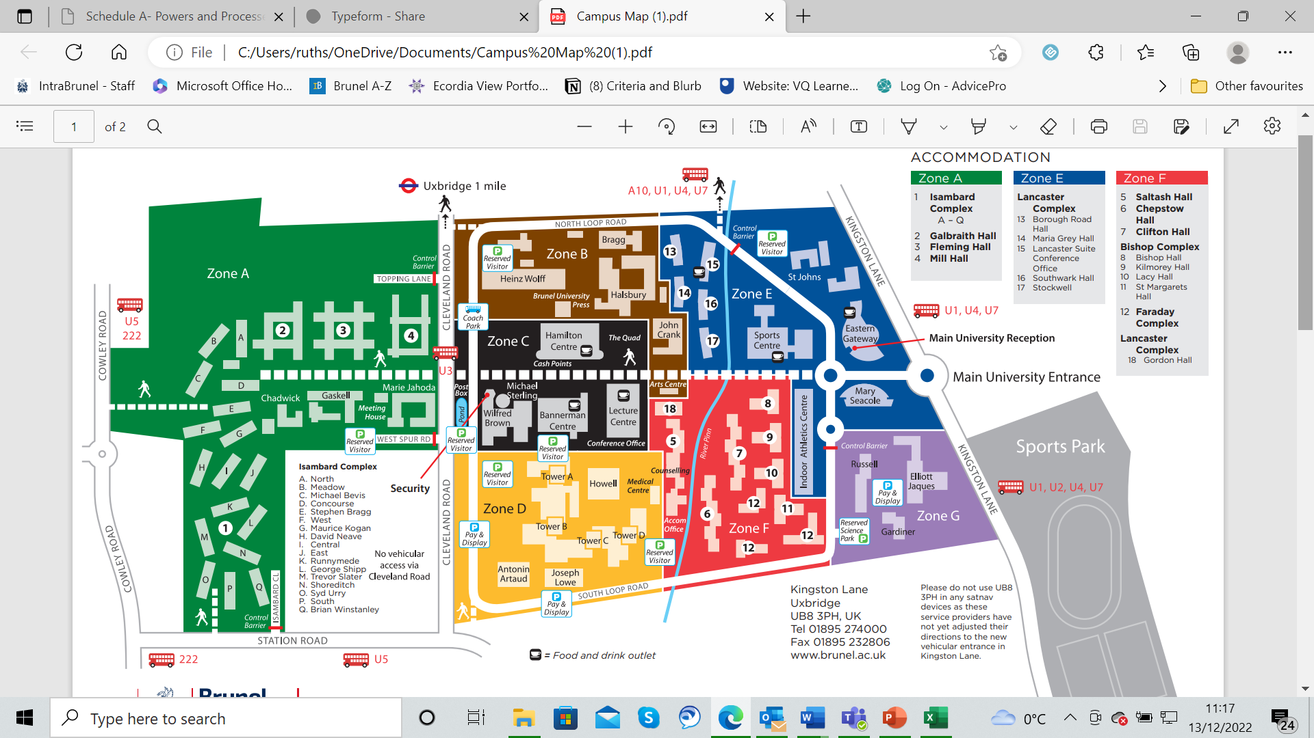

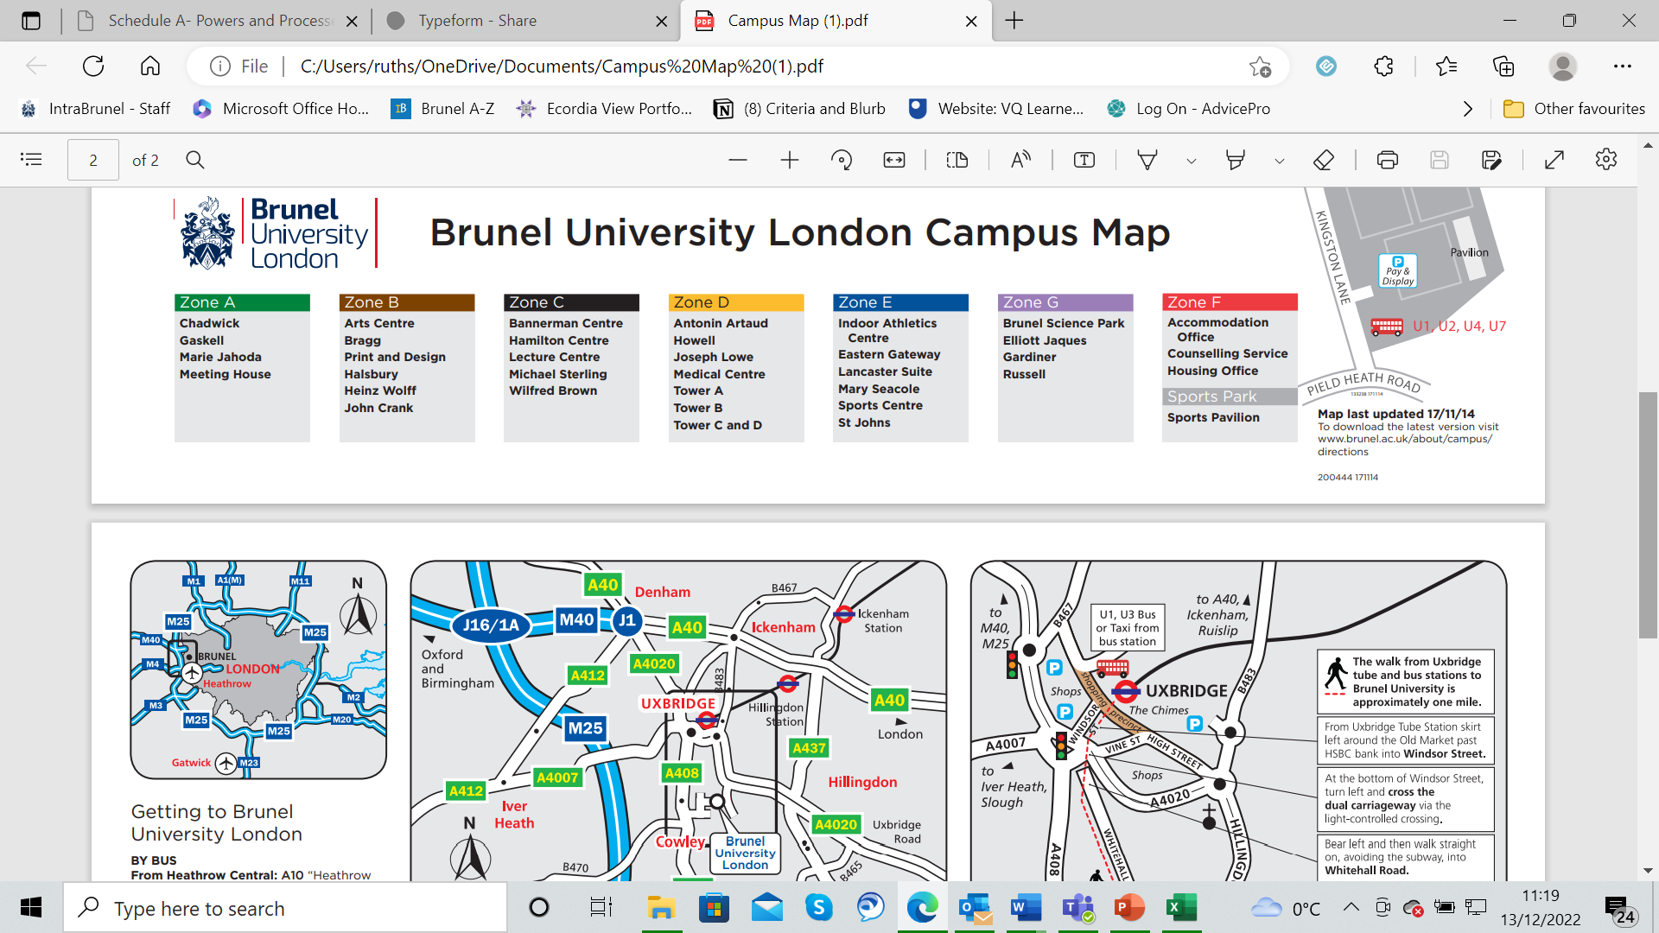
Candidates and campaigners are NOT allowed to campaign in:
- Halls
- Bannerman Centre
- Hamilton Centre
- Lecture Centre
- Any shops or eating establishments
- Anywhere off of campus

No more than 2 campaigners per candidate are allowed in campaign a zone at one time.

