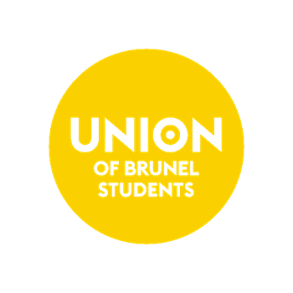
ROLE
DESCRIPTION

DISABLED
STUDENTS
OFFICER
Spring 2025

Updated: January 2023

ROLE DESCRIPTION
Position: Disabled Students Officer
Start date: 7th July 2025
End date: 10th July 2026
Hours of work: Part-Time, working 3 hours per week Monday – Friday (with commitment required to work outside regular working days on occasion as required).
Induction: 18th August – 22nd August
Responsible to: Student Voice Manager
Benefits:
- Opportunity to develop key leadership and negotiation skills, whilst acting to deliver positive impact on the experience of more than 17,000 student members
- Guest list entry + 1 Guests (you must be present) for Union club nights.
- 40% off Coffee in Locos (in line with staff discount offered at the time) to be eligible for this
Training:
- Full weeklong training and induction period
- Access to University training programme
- Role specific learning and development opportunities

ROLE REQUIREMENTS

Requirements:
- You must currently be enrolled at Brunel University.
- You must be studying for the academic year 24/25 (ideally for the whole year).
- You must have lived experience of living with a disability.
- You must be able to attend a remote campaign planning training session in August 2025.
- You must be able to work at least half of 1 day in the Union of Brunel Students office.

Qualities you need:
- Empathy.
- Trustworthiness, including honesty.
- Reliability, punctuality, and loyalty.
- Integrity, respect and courtesy.
- Responsibility, including accountability.
- Diligence, perseverance, self-management skills, and self-control.

You'll need to show:
- A commitment to promoting equality, diversity and inclusion.
- Excellent written and oral communication skills.
- Cultural sensitivity.
- Experience of building relationships with key stakeholders and decision makers
- The ability to build the trust of community groups
- Negotiation and persuasion skills
- The ability to work as part of a team
- Self-motivation and an ability to use initiative
- Organisational and project-management skills
- Good report-writing ability

The role entails you to:
- Research, apply and promote diversity initiatives and share best practice.
- Provide support on equality and diversity issues.
- Assess community needs and promote community cohesion.
- Promote changes within the Union, University and the wider community.
- Liaise with community groups and other relevant organisations.
- Interact with people at all levels and from a range of backgrounds.
- Act in the best interests of all communities at Brunel.

ROLE RESPONSIBILITIES

Responsibilities:
- As the Disabled Students Officer, you will support the promotion of an inclusive and accessible environment and advocate on behalf of disabled students.
- As the Disabled Students officer, you will bring awareness to the issues faced by students with both visible and invisible disabilities.
- As the Disabled Students officer, you will create 2 innovative campaigns that galvanize the Student Membership and encourages an accessible and inclusive environment.
- As the Disabled Student Officer, you will co-chair the Disabled Students Network (DSN).
- As the Disabled Students officer, you will inherit the mandatory legacy campaign of Disability Awareness Month and be allowed to choose a supplementary campaign that supports or celebrates students from racially minoritized backgrounds.
Legacy Campaign:
As the Disabled Students officer, you will lead the Student Union’s Disability Awareness Month, in accordance with the Disability Awareness Month theme of the year. The objective of the campaign is to raise awareness of the issues faced by students with disabilities and highlight the importance of accessibility, dignity, and inclusivity. Disability Awareness Month is from 16th November – 16th December.
Supplementary Campaign:
As the Disabled Students Officer, you will be encouraged to create a supplementary campaign that either brings awareness to the issues faced by students with disabilities or a disability-related cause.

KEY CONTACTS

As the Disabled Students Officer, you will work closely with:
- The Welfare and Inclusion President
- The Student Activities President
- The Disabled Students Network
- The Student Voice Manager
- The Student Activities Manager

